

**UNIVERSITY OF PETROLEUM & ENERGY STUDIES**

**College of Engineering Studies Dehradun**

**LAB FILE**

**Experiment 11**

Programme : B. Tech in Computer Science and Engineering with Specialization in DevOps

Course : Continuous Integration & Continuous Deployment Lab

No. of credits : 1

Semester : V

Session : July-December 2020

Batch : 2018-2022

Faculty : Dr. Hitesh Kumar Sharma

Submitted By:

Ingit Singhal

Sap id: 500068426

Roll No : R171218048

**Installing Vagrant and creating a Virtual Machine Using it**

**Screenshots**

**1. Download Vagrant and install it in your pc.**

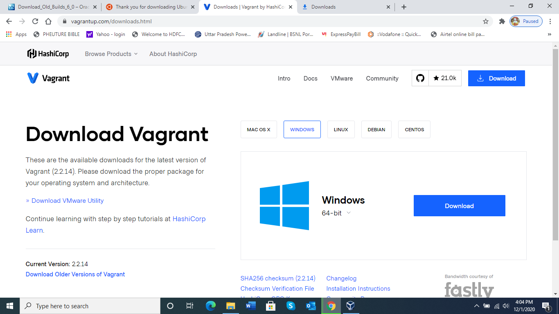

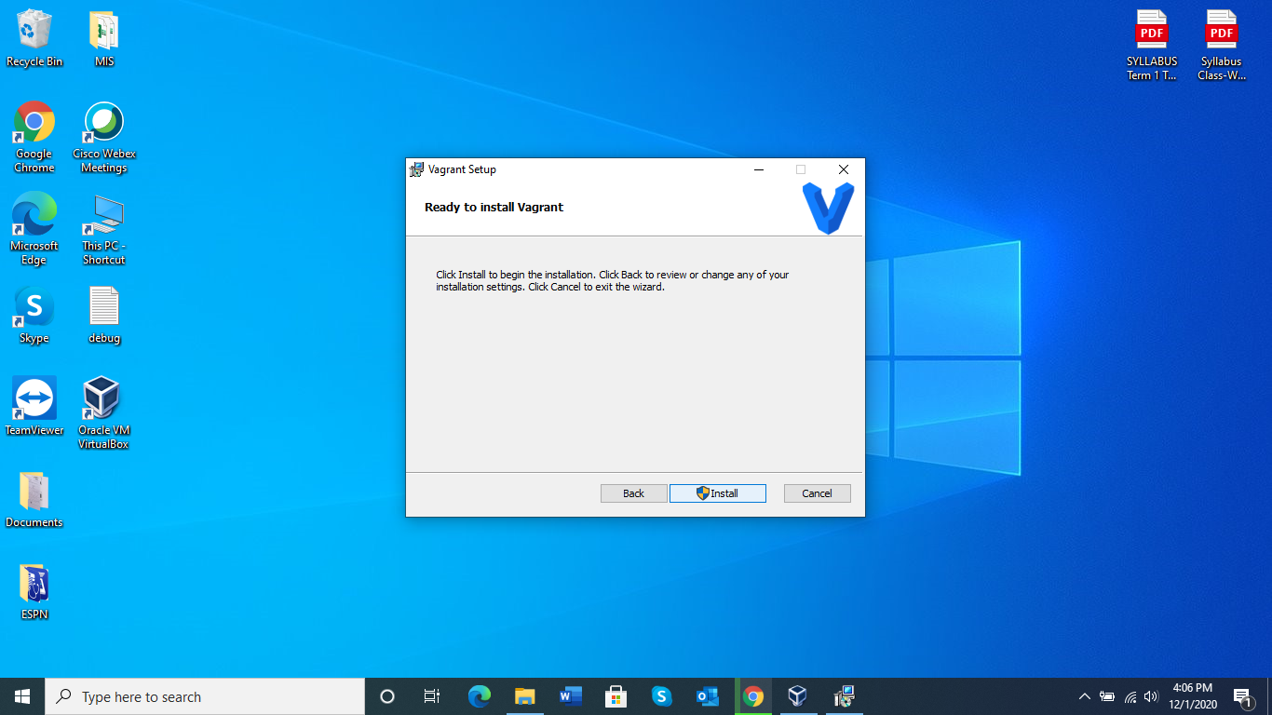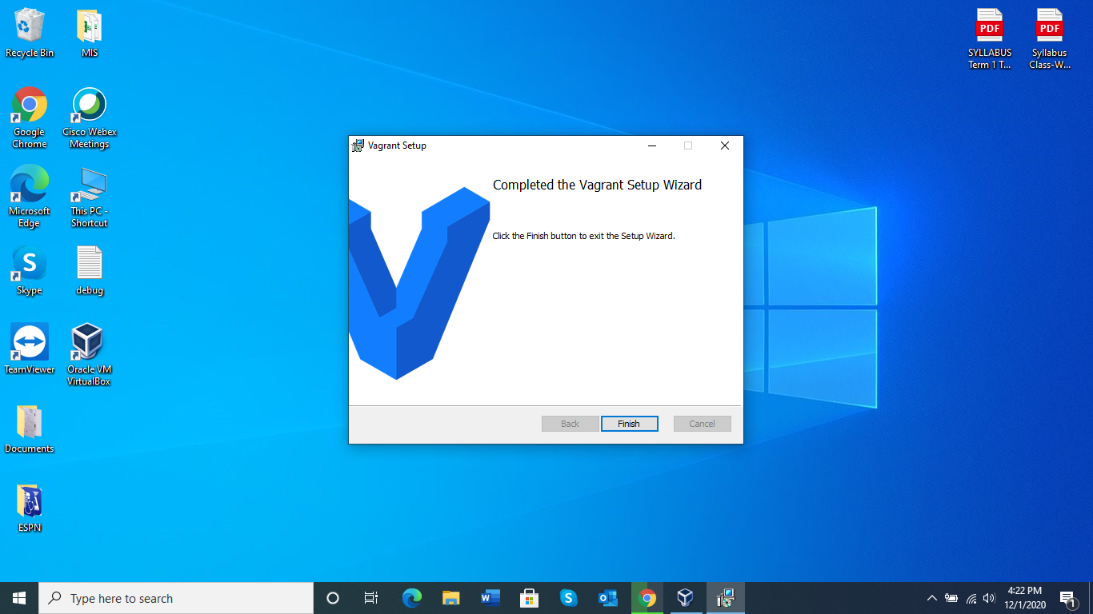

**2. Check it is working in your pc using command given below**

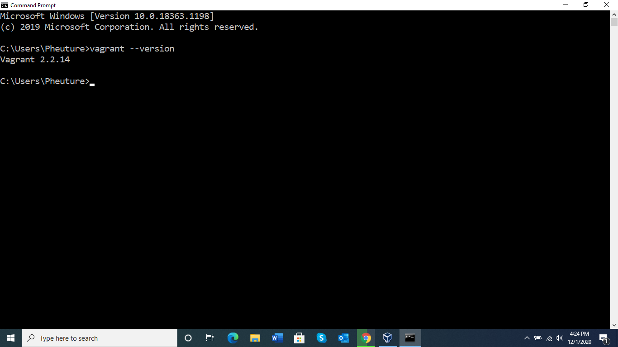

**3. Create a new directory and make a vagrant file using command “vagrant init”. Edit that file with the ubuntu iso file image.**

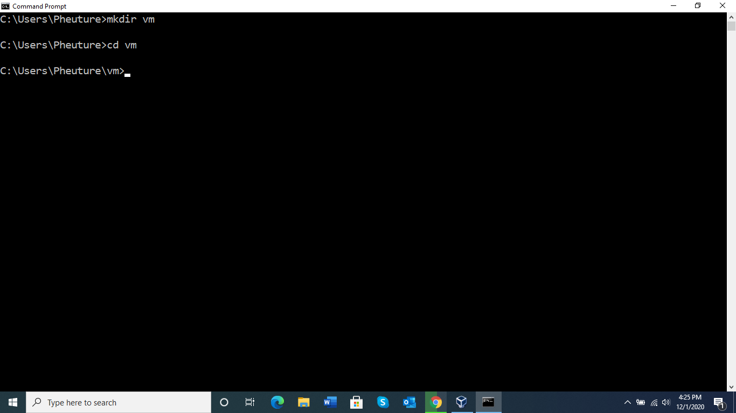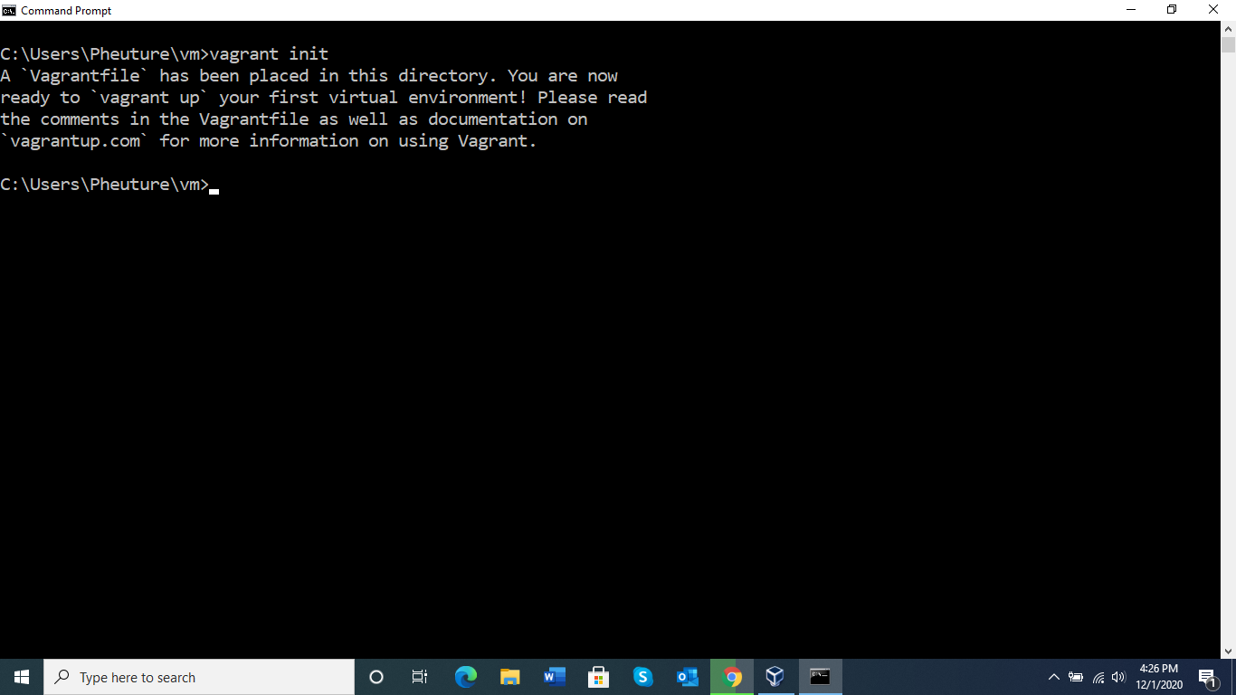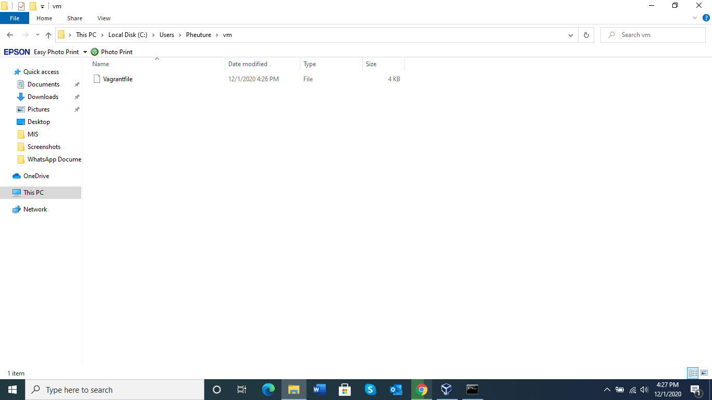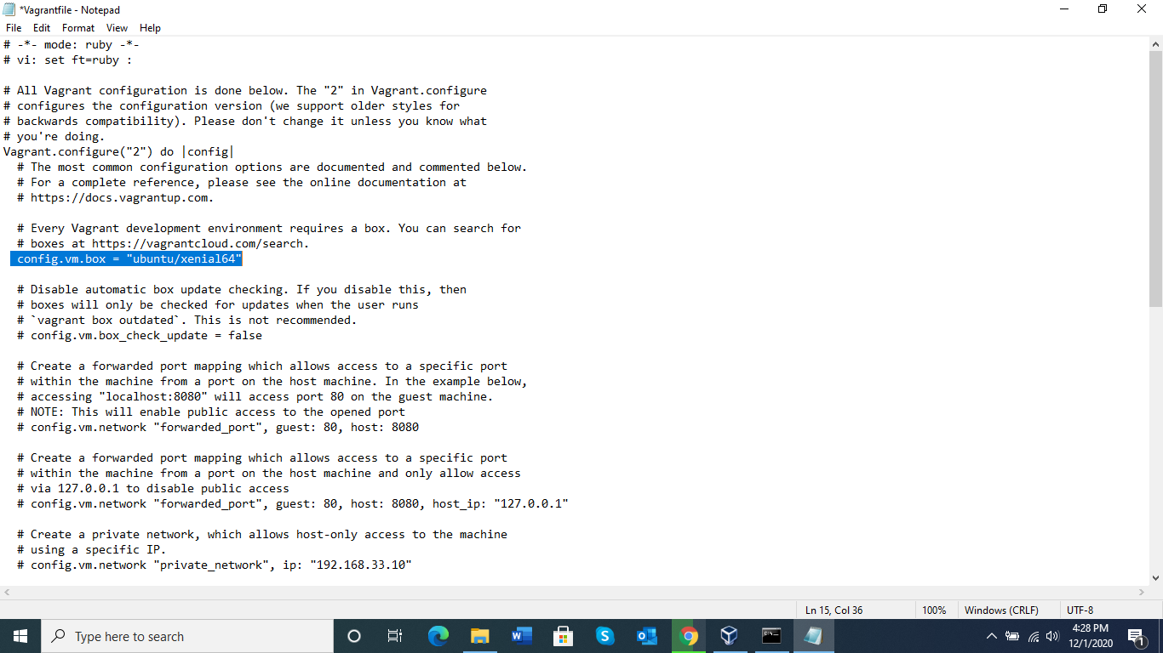

**4. Now run the command “vagrant up” to make it fully functional .**

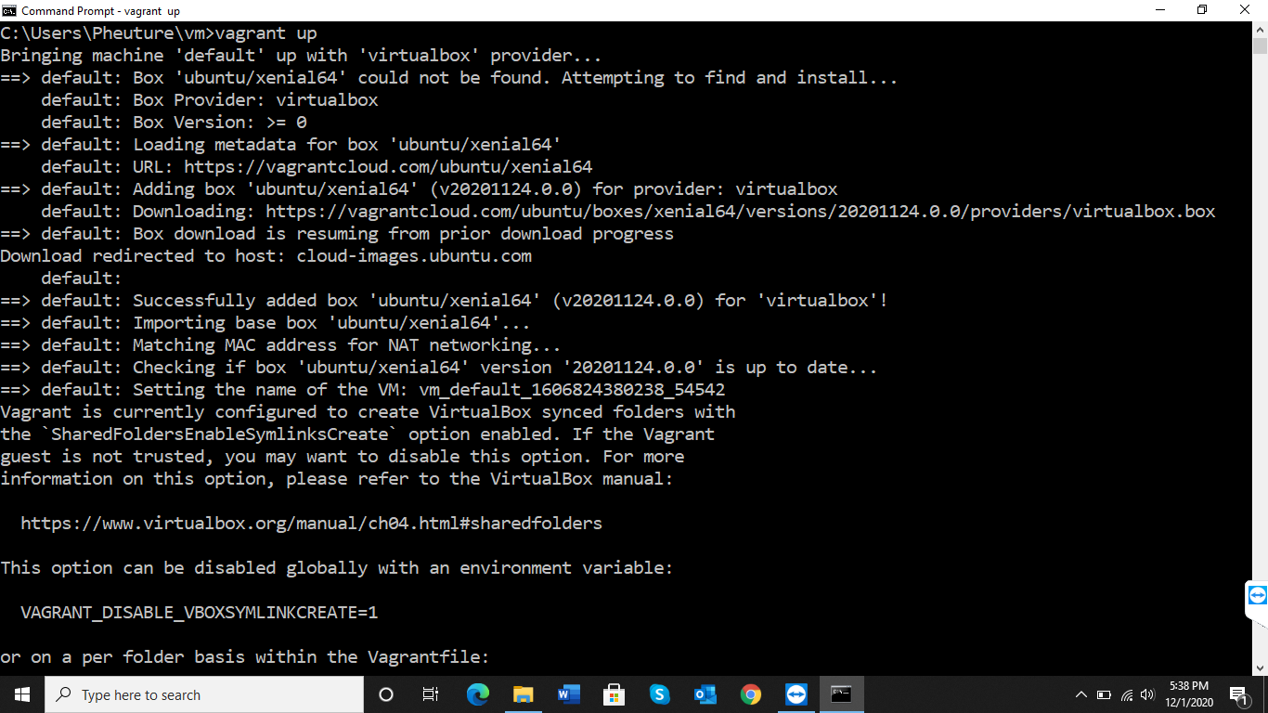

**5. Created a virtual machine using vagrant and by using command “vagrant ssh” command we start virtual box .**

